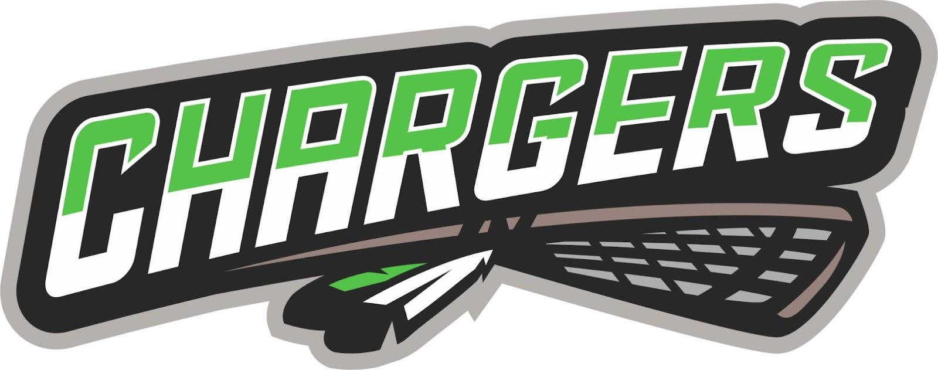
Chargers Lacrosse Association
PO Box
Carstairs, AB
T0M 0N0

Chargers AGM Meeting June 23, 2025
Members: Dean Neilsen (Pres), Annie Fox (VP), Michelle Ball (VP), Rob Andrews (Tres), Anne Marie Pardy, Jaclyn Fuhr (Registar), Robbi Spady, Christofer Atchison, Jeff Thompson, Austin Harding (Coach Coord), Heather Tolley (Fundraising), Blaga Goertzen, Jessica Bishop, Aaron Beaton, Cindy Fleming, Paula Richardson (discipline), Blanca Wiseman, Krystal Taylor, Nicole Dennsion, Ralene McCulloch, Kristina Jacques, Victoria Leier.
Excused: Rob Bayer
Acceptance of agenda: Jaclyn motion, all in favor
Previous minutes: read by Dean, motioned to accept: Chris Atchison, all in favor
Agenda items:
Voting on Board Positions: Vice President, Registrar, Treasurer, Equipment Coordinator, Discipline Director, Apparel Coordinator, Secretary, Coach Director
VP: Michelle Ball (acclaimed)
Registrar: Jaclyn Fuhr (acclaimed)
Treasurer: Rob Andrews (acclaimed)
Equipment: Nicole Dennison (acclaimed)
Discipline: Paula Richardson (acclaimed)
Apparel Coordinator: Krystal Taylor (acclaimed)
Secretary: Cindy Fleming
Coach Director: Austin Harding (acclaimed)

President:
Bylaw Change- VP in training. Motion to change the titles of positions from Vice-President and Vice-President in Training to Vice-President 1 and Vice-President 2.
Passed.
Season Recap - Looking forward to 2026
Vice Presidents Report:
-U15/U17 playoffs same weekend means they cannot pull up (stagger U11/U15?), and U15/17 playoffs on July long (parents weren’t happy)
Treasurer report:
Updated Financials:
$44,147.88 chequing account.
Profit/loss: $8K profit currently, budgeted for a loss, with income and expenses up and coming should end at a loss of approx $2500-3000.
BUDGET - to host tourn and playoffs, provide shirts for coaches,
Motion to accept report - passed
Registrar:
Reviewing that coaches have done all courses. Motion to accept from Ralene, passed.
Fundraising/Social Media update:
Waiting on cheque from Raffle Box, no involvement in Coffee fundraiser, bottle drive successful.
Suggestion on Instagram page.
Motion to accept report: Nicole, all in favor.

Coach Coordinator:
2 U11 coaches, Austin will do U13, Brett McK U15.
Motion to accept - Krystal, all in favor.
Equipment:
Spreadsheet started for equipment that needs to be replaced.
Goalie gear will go for cleaning upon return.
Bond cheques for goalie equipment next year
Each team gets 40 balls and returns 40 balls
Motion to accept report: Michelle, all in favor.
Discipline:
Nothing to report.
Reminder for next year: all kids under 18 (or not turning 18 in that year) on the floor need to be wearing a helmet.
Motion to accept - Annie, all in favor.
Apparel:
Nothing, motion to accept (Dean), all approved.
Scheduler:
Weds in Dids for U15/17 due to grad in Carstairs.
Motion to accept: Chris, all in favor.
Old Business:
NEW POLICIES:
Injury Policy - monetary/refund policy. Case by case basis? Based on games played, etc. ADD note: Injury Policy (under refund policy) will be dealt with on a case by case basis at the discretion of the board.
U17 driving policy - (steal from RMAA) - away games not permitted to drive themselves or team mates. Home games can drive themselves but must drive directly. (See policy from RMAA below)
(https://www.renegadesminorhockey.com/wp-content/uploads/sites/2439/2024/11/I-RMHA-Driving-Policy.pdf)
Parent/Coach Conduct:
New Business:
Next Meeting: August

